Atividades

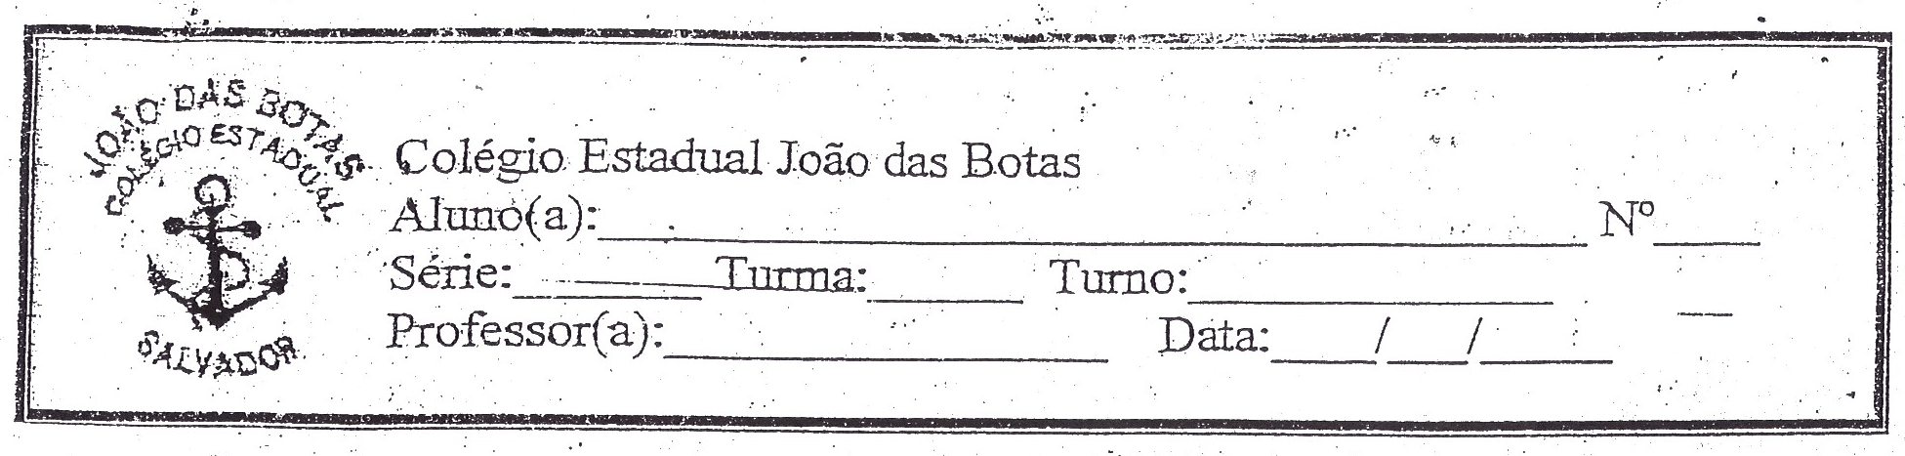

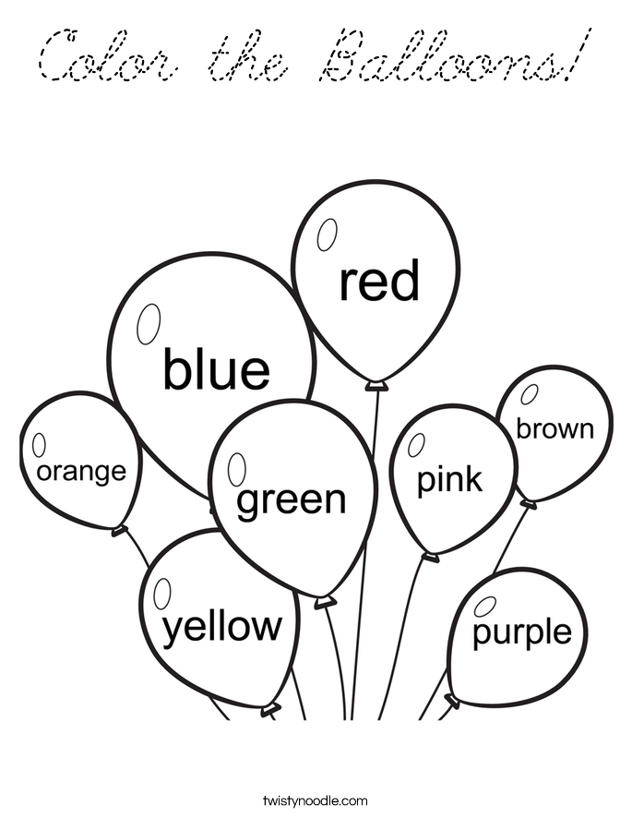

Cut and paste fruits.
Then put the name of each of them.
(Recorte e cole frutas. Em seguida coloque o nome de cada uma delas.)

YELLOW FRUITS

GREEN FRUITS

RED FRUITS

Type the name of the word under the correct picture. Use the words in the box.
(Escreva o nome da palavra sob a imagem correta. Utilize as palavras na caixa.)

Breakfast Lunch

Snack Dinner

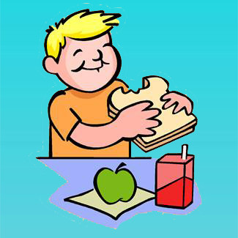
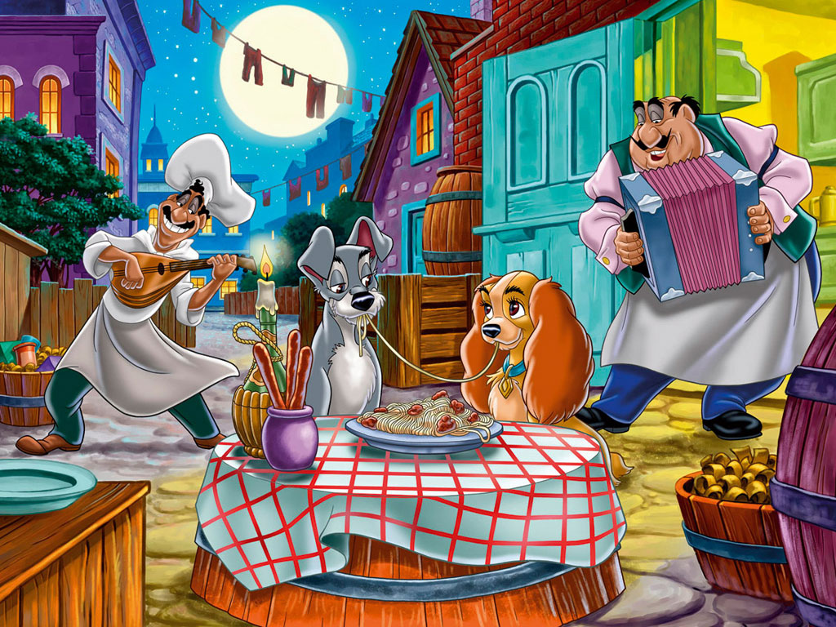

________________________ ________________________

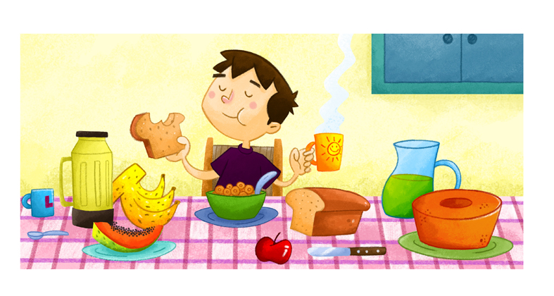
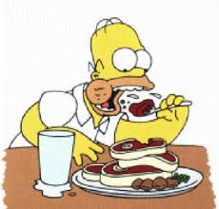

2 - Complete the sentences.

________________________ ________________________

I - Classifique os seguintes substantivos em contáveis ou incontáveis.
1. | Apple
2. | Milk
3. | Pineapple
4. | Orange
5. | Apple juice

II - Escreva Countable ou Uncountable para cada alimento.

a)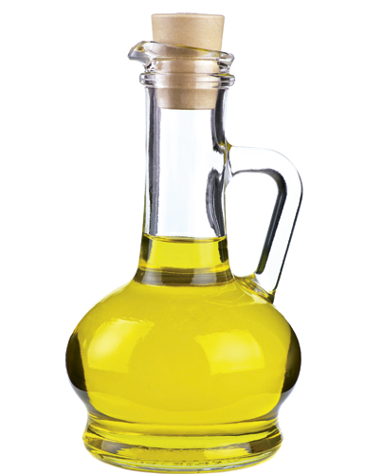____________________
b)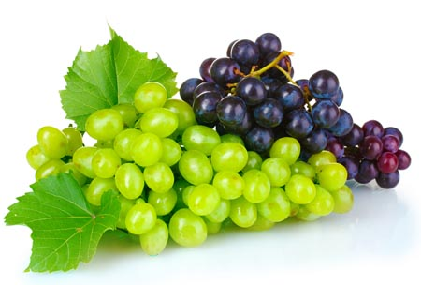____________________
c)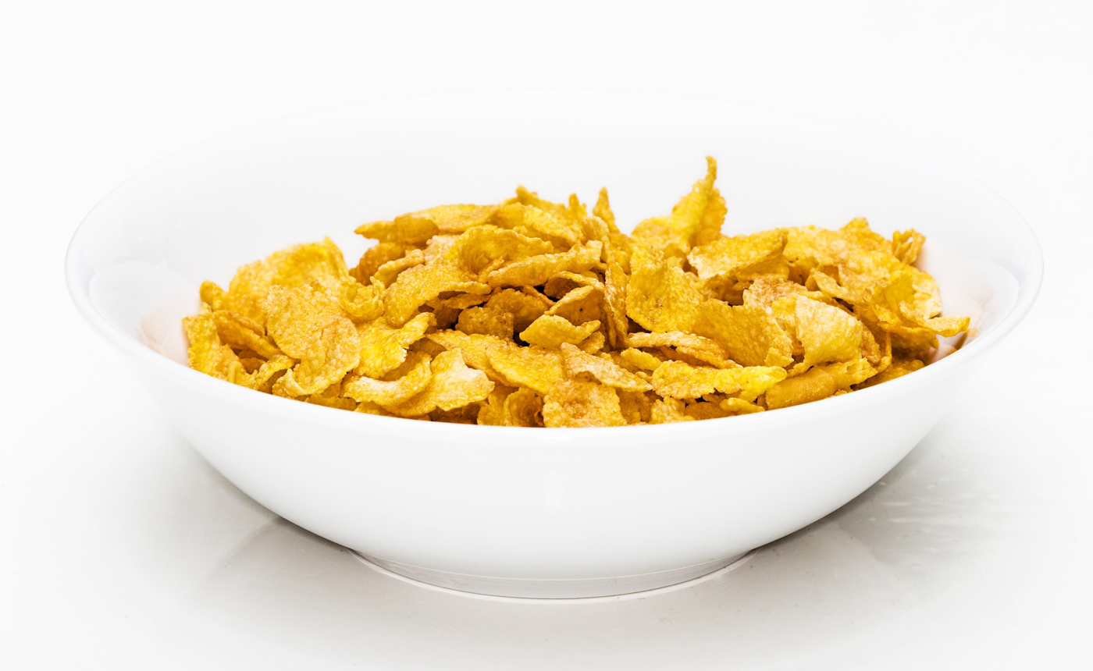_____________________
d) _____________________
e) 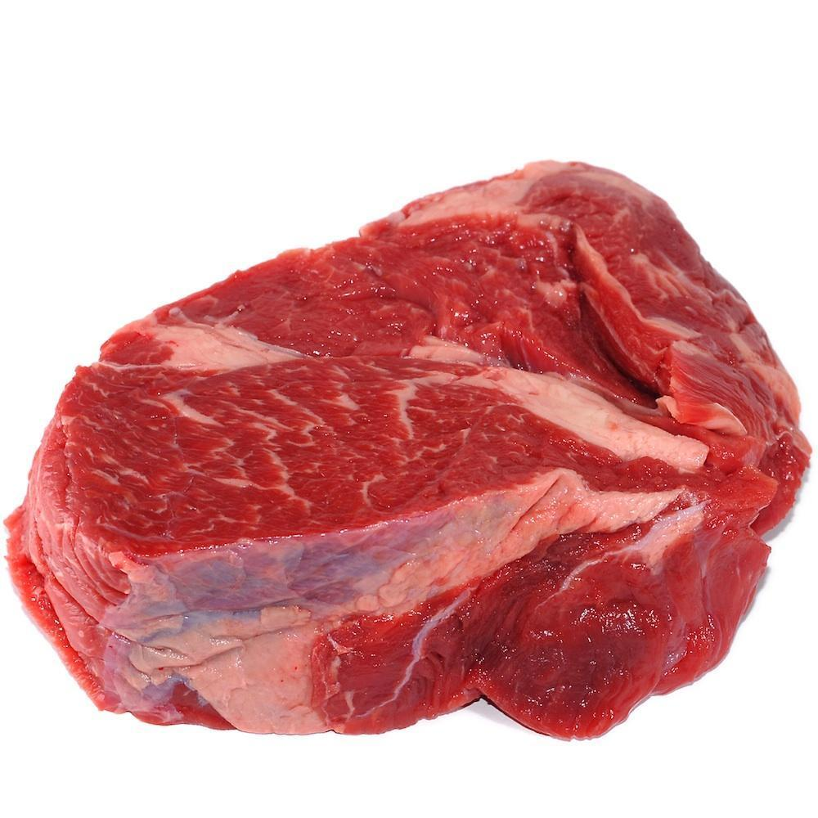 ___________________

Old MacDonald Had a Farm (Kinderlieder)

# Old MacDonald had a farm, E-I-E-I-O.
And on his farm he had a cow, E-I-E-I-O.
With a "moo-moo" here and a "moo-moo" there.
Here a "moo" there a "moo"
Everywhere a "moo"!
Old MacDonald had a farm, E-I-E-I-O.
# Old MacDonald had a farm, E-I-E-I-O.
And on his farm he had some sheep, E-I-E-I-O.
With a "baa baa" here and a "baa baa" there.
Everywhere a "baa baa"!
With a "moo-moo" here and a "moo-moo" there.
Here a "moo" there a "moo"
Everywhere a "moo"!
Old MacDonald had a farm, E-I-E-I-O.
And on his farm he had a pig, E-I-E-I-O.
With an "oink" here and an "oink" there.
Here an "oink" there an "oink"
Everywhere an "oink"!
With a "baa baa" here and a "baa baa" there.
Everywhere a "baa baa"!
With a "moo-moo" here and a "moo-moo" there.
Here a "moo" there a "moo"
Everywhere a "moo"!
Old MacDonald had a farm, E-I-E-I-O.
# The other animals on old MacDonald´s farm are:
# a duck (quack-quack)
# a house (neigh- neigh)
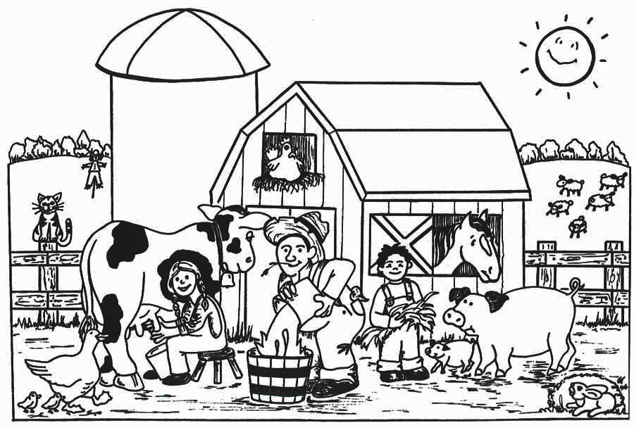

I- Assinale a alternativa correta usando com "a / an".
1. | There is rabbit on your table.
2. | Can you buy chicken for me?
3. | It is elephant.
4. | Do you have big fish?
5. | Do you prefer to have cat or dog?
6. | There is lion in the Zoo.
7. | Would you like to have horse?
8. | Carlos the house has black spider.
9. | I want the animal!
10. | I need wolf.

1. Escolha a opção que melhor traduz os números abaixo para o inglês.
13:______________[thirty, thirteen]
16:______________[sixty, sixteen]
33:______________[thirteen three, thirty three]
22:______________[twelve two, twenty two]
8:_______________[eight, eighty]
10:______________[teen, ten]
100:_____________[one hundred, one thousand]
1000:____________[one million, one thousand]
11:______________[eleven, eleventh]
99:______________[ninety nine, nineteen nine]
2. Como se diz "2014" e "2015" em inglês?
a. Two thousand fourteen / two thousand fifty
b. Two thousand forty / two thousand fifteen
c. Two thousand fourteen / two thousand fifteen
d. Two hundred fourteen / two hundred fifteen
3. Os números de "13" a "19" em inglês terminam em:
a. Ten
b. Ty
c. Teen

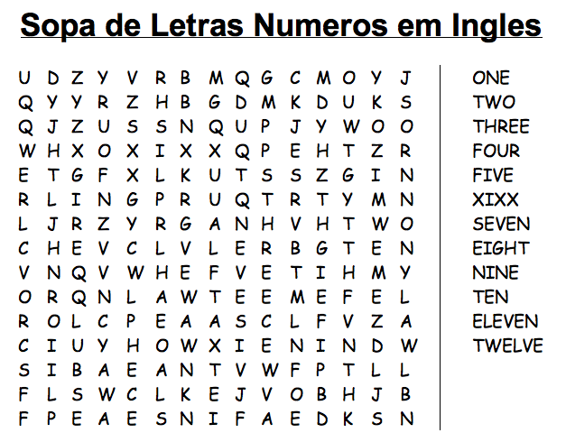

1 – Complete the dialogue below. Use the questions in the box.

What color do you prefer? Good afternoon, can I help you?

How much is it? Which size?

A: __________________________________________

B: Yes thanks, I'm looking pants for my father.

A: __________________________________________

B: Medium.

A: __________________________________________

B: Mustard.
A: Here you are.

B: __________________________________________
It is sixty-seven dollars.
I’ll take it.

2 - In the dialogue which is the size of pants? Check the correct alternative:

a) XS
b) M
c) XL
d) S
e) L
3 - In the dialogue which is the chosen color? Check the correct alternative:

a) Brown
b) Orange
c) White
d) Mustard
e) Grey
4 - How much is pants?

_________________________________________

Head, Shoulders, Knees, And Toes.

Head, shoulders, knees, and toes.
Head, shoulders, knees, and toes.
Eyes. ears. mouth and nose.
Head, shoulders, knees, and toes.

Head, shoulders, knees, and toes.
Head, shoulders, knees, and toes.
Eyes. ears. mouth and nose.
Head, shoulders, knees, and toes.

Head, shoulders, knees, and toes.
Head, shoulders, knees, and toes.
Eyes. ears. mouth and noooooooooooooooooooooooooooose.
Head, shoulders, knees, and toes.
Dun dun dun dah! alright! hah hah!

Cabeça, ombros, joelhos, e dedos pés.

Cabeça, ombros, joelhos e dedos do pé.
Cabeça, ombros, joelhos e dedos do pé.
Olhos. Ouvidos. Boca e nariz.
Cabeça, ombros, joelhos e dedos do pé.

Cabeça, ombros, joelhos e dedos do pé.
Cabeça, ombros, joelhos e dedos do pé.
Olhos. Ouvidos. Boca e nariz.
Cabeça, ombros, joelhos e dedos do pé.

Cabeça, ombros, joelhos e dedos do pé.
Cabeça, ombros, joelhos e dedos do pé.
Olhos. Ouvidos. Boca e naaaaaaaaaaaaaaaaaaaaaarizzzzzzzzzz.
Cabeça, ombros, joelhos e dedos do pé.
Dun dun dun dah! tudo bem! hah hah

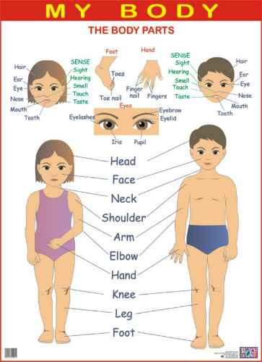

I – Complete corretamente. Use o subject pronouns.

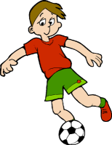_____ likes to play football. (Tom)  ______ like to play. (Mary and I)

 This am _____. (Eu) 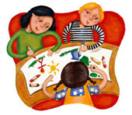 ______ are drawing. (The students)

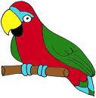 ____ has colourful feathers. (The parrot / Papagaio)

II - Exercícios sobre o verbo To Be no presente:
Complete com a forma correta do verbo To Be (am, is, are):

01) He ___ a doctor.

02) I ___ a doctor.

03) They ___ doctors.

04) You ___ a doctor.

05) You ___ doctors.

06) Mary ___ a doctor.

07) Bill and Susan ___ doctors.

08) Sue and I ___ doctors.

09) The bus ___ green.

10) The buses ___ green.

1- Passem as frases com o verbo "to be" para as formas negativa e interrogativa.
a)
Afirmativa: I am a student.
Negativa:________________________________________________________________
Interrogativa:_____________________________________________________________
b)
Afirmativa: You are my teacher.
Negativa:________________________________________________________________
Interrogativa:_____________________________________________________________
c)
Afirmativa: He is a boy.
Negativa:________________________________________________________________
Interrogativa:_____________________________________________________________
d)
Afirmativa: She is a girl.
Negativa:________________________________________________________________
Interrogativa:_____________________________________________________________
e)
Afirmativa: It is my house.
Negativa:________________________________________________________________
Interrogativa:_____________________________________________________________
f)
Afirmativa: We are friends.
Negativa:________________________________________________________________
Interrogativa:_____________________________________________________________
g)
Afirmativa: They are soccer players.
Negativa:________________________________________________________________
Interrogativa:_____________________________________________________________

Whip My Hair (Willow Smith)

I whip my hair back and forth
I whip my hair back and forth (just whip it)
I whip my hair back and forth
I whip my hair back and forth (whip it real good)
I whip my hair back and forth
I whip my hair back and forth
I whip my hair back and forth
I whip my hair back and forth

Hop up out the bed turn my swag on
Pay no attention to them haters cuz we whip em off
And we ain't doing nothing wrong
So dont tell me nothing, I'm just trying to have fun
So keep the body Jumping

So whats up (yea)
And I'll be doing what to do
We turn our back
And whip our hair and just shake them off
Shake them off, shake them off,shake them off

Don't let haters keep me off my grind
Keep my head up I know I'll be fine
Keep fighting until I get there
When I'm down and I feel like giving up

I whip my hair back and forth
I whip my hair back and forth (just whip it)
I whip my hair back and forth
I whip my hair back and forth (whip it real good) (3X)

I whip my hair back and forth (4X)

I'ma get more shine than a little bit
Soon as I hit the stage applause I'm hearing it
Whether its black stars black cars I'm feeling it
But can't none of them whip it like I do
I, I gets it in mmmm yeah I go hard
When they see me pull up I whip it real hard
I whip it real hard, real hard, I whip it real hard

Don't let haters keep me off my grind
Keep my head up I know I'll be fine
Keep fighting until I get there
When I'm down and I feel like giving up

I whip my hair back and forth
I whip my hair back and forth (just whip it)
I whip my hair back and forth

I whip my hair back and forth (whip it real good)
I whip my hair back and forth
I whip my hair back and forth (just whip it)
I whip my hair back and forth
I whip my hair back and forth (whip it real good) (2X)

I whip my hair back and forth
I whip my hair back and forth (ok, ok just whip my hair)
I whip my hair back and forth
I whip my hair back and forth (whip it real good)
I whip my hair back and forth

All my ladies if you feel you are gonna do it
Do it do it whip your hair
Dont' matter if its long, short
Do it do it whip your hair

All my ladies if you feel you are gonna do it
Come on do it do it whip your hair
Dont' matter if its long, short
Do it do it whip your hair (your hair, your hair)

I whip my hair back and forth
I whip my hair back and forth (just whip my hair) (6X)

I whip my hair back and forth (5X)

I whip my hair back and forth
I whip my hair back and forth (just whip it)
I whip my hair back and forth
I whip my hair back and forth (whip it real good) (2X)

I whip my hair back and forth
I whip my hair back and forth
I whip

